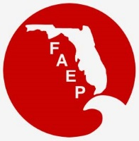 | 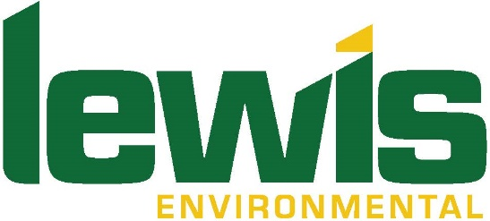  FAEP CHAPTER MEETINGS Thanks to our sponsor!  MARCH 2019
Chapter |  | Event | Speaker/Affiliation | Date and Time | Location | Contact
Central |  | Networking Social |  | Thurs, March 21  5:00 pm – 8:00 pm | Ace Café  100 W Livingston Street  Orlando, FL | RSVP to  thodgson@feccorporation.com
Central/ Tampa Bay |  | Golf Tournament |  | Fri, March 8  12:30 pm – 6:00 pm | Huntington Hills Country Club  Lakeland, FL | http://events.r20.constantcontact.com/register/event?oeidk=a07eg0s9cip1a9b5207&llr=wc6bnzmab
Northeast |  | TBA
Northwest |  | Lunch and Learn | Cathy Hardin, Escambia County  Forester with the Florida Forest Service | Fri, March 15  12:00 pm | Institute for Human and Machine Cognition  40 S Alcaniz Street  Pensacola, FL 32502 | RSVP to  wstokes@clarkpartington.com
South |  | Broward County Water Matters Day | SFAEP will have an exhibit booth | Sat, March 9  9:00 am to 3:00 pm | Tree Tops Park  3900 SW 100th Ave  Davie, FL | RSVP to  pedro@stiassni.com
South |  | Sandspur Islands Cleanup | SFAEP will lead a kayaking trip to the islands | Sat, March 30  8:30 am | Oleta River State Park  3400 NE 163rd St, North Miami Beach, FL | RSVP to bvoelker@esceincesinc.com
Southwest |  | Networking Social |  | Fri, March 22  6:00 pm | Southern Fresh Farms | RSVP to  Arielle@thanaples.com
Tallahassee |  | Member Appreciation Event | Animal Presentation, Zipline, Dinner  Networking (Pre-registration strongly encouraged because of limited space) | Fri, March 8  3:30 pm-8:00 pm | Tallahassee Museum  3945 Museum Road  Tallahassee, FL 32310 | For information on upcoming events visit:  http://www.faep-tally.com/
Tampa Bay/ Central |  | Golf Tournament |  | Fri, March 8  12:30 pm – 6:00 pm | Huntington Hills Country Club  Lakeland, FL | http://events.r20.constantcontact.com/register/event?oeidk=a07eg0s9cip1a9b5207&llr=wc6bnzmab
Tampa Bay |  | Luncheon – Ocean Observations in Support of Maritime Transportation Operations and Infrastructure | Mark E. Luther, PhD -  Associate Professor and Director  Center for Maritime and Port Studies  USF College of Marine Science | Wed, March 20  11:30 am - 1:00 pm | Brio  International Mall  2223 N Westshore Blvd Tampa, FL 33607 | For information on  upcoming events visit: http://www.tbaep.org/events
Treasure Coast |  | Fun run/walk and social |  | Wed, March 27  5:30 pm – 7:30 p.m. | Jupiter Ridge Natural Area  1800 South US Highway 1  Jupiter, FL 33477 | RSVP to  tcc.faep@gmail.com

Thank you to our sponsor Lewis Environmental. Please contact Rick Scoppa at (484) 374-0897 or rscoppa@DiscoverLEWIS.com.

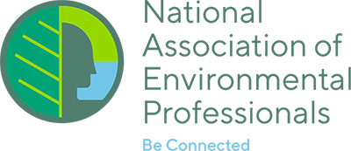
NAEP UPDATE

2019 NAEP Conference – Sponsor and Exhibitor Opportunities Available!
Excitement is brewing in Baltimore in anticipation of the next NAEP Conference, to be held there on May 19–23, 2019. Information on Sponsor and Exhibitor opportunities is available at https://naep.memberclicks.net/2019-conference-sponsorship.

Call for Papers for the NAEP Environmental Practice Journal
Environmental Practice, the peer-reviewed journal of the National Association of Environmental Professionals (NAEP) and published by Taylor & Francis, is soliciting original manuscripts from the professional and academic communities on a continuous basis. Publishing in Environmental Practice is also a great venue to showcase your expertise and continue your professional development. More information can be found at: https://www.naep.org/environmental-practice-journal.

Call for Articles for the News for the Environmental Professional: The Official Newsletter of the NAEP
The NAEP newsletter is published four times a year and emailed to all NAEP members. The newsletter is published in mid-February, May, August and November. Articles are accepted continuously, but the deadline for submissions for a particular newsletter is the end of the month prior to publication—for example, the deadline for the February issue deadline is January 31st. If you are interested in submitting an article, email newsletter@naep.org. More information on the newsletter is available at https://naep.memberclicks.net/naep-e-newsletter.

Below is the link to the February 15, 2019, issue of the National Desk. We are very excited to offer this NAEP and Chapter Affiliate Member benefit. The NAEP National Desk is a bi-weekly publication of current national issues affecting the environmental professional.
The articles listed below are included in this issue of the National Association of Environmental Professionals (NAEP) :
- Lead NEPA Story: White House reviews plan for weighing emissions under NEPA
- Clean Water Act: Army Corps to slash state permit review times
- NEPA: Code name 'mushroom': FOIA suit sniffs out deception
- Clean Water Act: A hunter's view: No such thing as an isolated wetland
- NEPA: Interior mulls commercial-scale project on Nevada tribal lands

