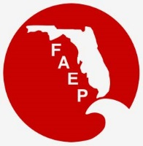 | 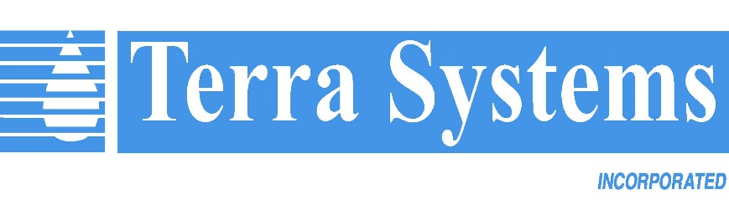  FAEP CHAPTER MEETINGS Thanks to our sponsor!  FEBRUARY 2019
Chapter |  | Event | Speaker/Affiliation | Date and Time | Location | Contact
Central |  | Orlando Magic  Basketball Game |  | Thurs, Feb 7  6:30 pm – 10:00 pm | Amway Center  400 West Church Street  Orlando, FL 32801 | For wait list, contact  Todd Hodgson: thodgson@feccorporation.com
Central |  | Luncheon - Coastal Habitat Restoration in Florida | Frank J. Gidus, II - Director of Habitat and Environmental Restoration,  Coastal Conservation Association | Thurs, Feb 21  11:45 am – 1:00 pm | The Tap Room  Dubsdread Country Club  549 West Par Street  Orlando, FL 32804 | RSVP to Todd Hodgson:  thodgson@feccorporation.com
Northeast |  | Networking Social |  | Wed, Feb 27  5:00 pm – 8:00 p.m. | Wicked Barley Brewing Company  4100 Baymeadows Road, Jacksonville, FL 32217 | https://www.facebook.com/NEFAEP/
Northwest |  | Luncheon - Petroleum Remediation Updates | Stephen Hanks,  Wood | Fri, Feb 15  12:00 pm | Institute of Human and Machine Cognition  40 S Alcaniz Street  Pensacola, FL | RSVP to  Ashley.Jansen@nexteraenergy.com
South |  | Florida Panthers  Hockey Game |  | Sat, Feb. 23  5:00 pm | BB&T Center  1 Panther Parkway  Sunrise, FL | RSVP to Jen Savaro: jsavaro@esciencesinc.com
Southwest |  | Networking Social |  | Fri, Feb 8  6:00 pm – 8:00 p.m. | Celebration Food Truck Park  Naples, FL | RSVP to:  Arielle@thanaples.com
Tallahassee |  | Social |  | Thurs, Feb 21  5:30 pm – 7:30pm | TBA | For information on  upcoming events visit:  http://www.faep-tally.com/  For more information email Tim Perry and tperry@ohfc.com
Tampa Bay |  | Luncheon - Brownfields | Frank L. Hearne, Esq., Shareholder, Mechanik Nuccio Hearne & Wester, P.A. | Wed, Feb 20  11:30 am - 1:00 pm | Brio  International Mall  2223 N Westshore Blvd Tampa, FL 33607 | For information on  upcoming events visit: http://www.tbaep.org/events
Treasure Coast |  | Networking Social |  | Wed, Feb 20  5:30 pm – 8:00 p.m. | Batch New Southern Kitchen and Tap  223 Clematis Street  West Palm Beach, FL 33401 | RSVP to:  tcc.faep@gmail.com
Treasure Coast |  | Student Event – Discussion and networking with experienced environmental professionals |  | Thurs, Feb 28  6:00 pm – 8:00 p.m. | FAU Harbor Branch Oceanographic Institute  5600 US-1  Fort Pierce, FL 34946 | RSVP to:  tcc.faep@gmail.com

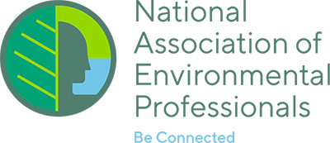
NAEP UPDATE

2019 NAEP Conference – Sponsor and Exhibitor Opportunities Available!
Excitement is brewing in Baltimore in anticipation of the next NAEP Conference, to be held there on May 19–23, 2019. Information on Sponsor and Exhibitor opportunities is available at https://naep.memberclicks.net/2019-conference-sponsorship.

Call for Papers for the NAEP Environmental Practice Journal
Environmental Practice, the peer-reviewed journal of the National Association of Environmental Professionals (NAEP) and published by Taylor & Francis, is soliciting original manuscripts from the professional and academic communities on a continuous basis. Publishing in Environmental Practice is also a great venue to showcase your expertise and continue your professional development. More information can be found at: https://www.naep.org/environmental-practice-journal. If you have any questions, please feel free to contact Dr. Frank J. Dirrigl, Jr., Editor-in-Chief at frank.dirrigl@utrgv.edu

Call for Articles for the News for the Environmental Professional: The Official Newsletter of the NAEP
The NAEP newsletter is published four times a year and emailed to all NAEP members. The newsletter is published in mid-February, May, August and November. Articles are accepted continuously, but the deadline for submissions for a particular newsletter is the end of the month prior to publication—for example, the deadline for the February issue deadline is January 31st. If you are interested in submitting an article, email newsletter@naep.org. More information on the newsletter is available at https://naep.memberclicks.net/naep-e-newsletter.

