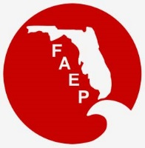 | FAEP CHAPTER MEETINGS  OCTOBER 2019
Chapter |  | Event | Speaker/Affiliation | Date and Time | Location | Contact
Central |  | Networking Social |  | Thurs, October 10  5:00 pm - 7:00 pm | Grills Seafood Restaurant and Bar-Rockledge  6075 N US Hwy 1  Melbourne, FL 32940 | https://www.cfaep.org/
Central |  | Luncheon - Water Wetlands and Wildlife | Mark Sees  Orlando Wetland Park | Thurs, October 24  11:45 am - 1:00 pm | The Tap Room  Dubsdread Country Club  549 West Par Street  Orlando, FL 32804 | https://www.cfaep.org/
Northeast |  | TBA
Northwest |  | TBA
South |  | Networking Social with  NAEP Board of Directors |  | Fri, October 18  time TBD | Fort Lauderdale, FL | RSVP to John.Abbott@wginc.com
South |  | Coral Species ID and Beach Watch Stress ID Training | Erik Neugaard  Port Everglades | Wed, October 23  5:00 pm- 7:30 pm | 1850 Eller Drive, Fort Lauderdale, FL | RSVP to eneugaard@broward.org
South |  | Quarterly Cleanup of  Sandspur Islands |  | Sat, October 26  8:30 am- 12 noon | Oleta River State Park  3400 NW 163rd St, North Miami Beach, FL | RSVP to bvoelker@esciencesinc.com
Southwest |  | Networking Social |  | Tues, October 29  6:00 pm – 8:00 pm | Millennial Brewing Co  Fort Myers, FL | For more information: swfaep.org or membership@swfaep.org
Tallahassee |  | Networking Social |  | Thurs, October 17  5:30 pm – 7:30 pm | The Brass Tap - Midtown  1321 Thomasville Road  Tallahassee, FL 32303 | Register here!
Tampa Bay |  | Luncheon - The Imperiled Species Management Plan: Focusing on the Southeast American Kestrel Species Action Plan | Jennifer Goff  Office of Conservation Planning Services, Division of Habitat and Species Conservation  Florida Fish & Wildlife  Conservation Commission | Wed, October 23  11:30 am – 1:00 pm | Brio  International Mall  2223 N Westshore Blvd Tampa, FL 33607 | http://www.tbaep.org/events
Treasure Coast |  | Coastal Resiliency Panel | Panel of experts discuss coastal resiliency - the challenges, successes and emerging tools used to protect our coasts | Thurs, October 17  5:30 pm – 8:00 pm | Loggerhead Marinelife Center  14200 US Highway 1  Juno Beach, FL 33408 | RSVP to  tcc.faep@gmail.com

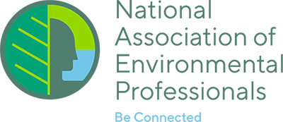
NAEP UPDATE

SAVE THE DATE - NAEP invites you to participate in the 2020 NAEP Annual Conference and Training Symposium in sunny Fort Lauderdale on May 18-22, 2020!

Abstracts are currently being accepted for presentations, posters, workshops, and special sessions. Contact Nic Frederick at nfrederick@dawson8a.com for any questions or to volunteer to lead a track session. Deadline for abstracts is October 11. www.naep.org

