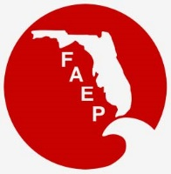 | 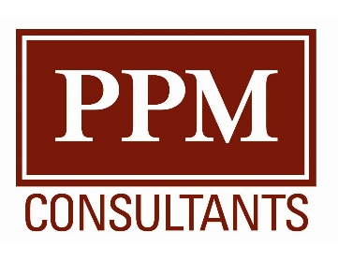  FAEP CHAPTER MEETINGS Thank you to our sponsor!  MAY 2019
Chapter |  | Event | Speaker/Affiliation | Date and Time | Location | Contact
Central |  | Networking Social |  | Thurs, May 16  5:00 pm – 7:00 pm | Millers Ale House  1251 Lee Rd  Winter Park | RSVP to Todd Hodgson:  thodgson@feccorporation.com
Northeast |  | Luncheon discussing PFAS | Nathan Eklund, Pace Analytical | Wed, May 29  12:00 pm | Embassy Suites,  9300 Baymeadows Road Jacksonville, FL 32256 | RSVP to Killian Eckert:  keckert@mechlingeng.com
Northwest |  | Lunch and Learn | Taylor Engineering; Artificial Reef Construction | Wed, May 17  12:00 pm | Institute for Human and Machine Cognition  40 S Alcaniz Street  Pensacola, FL 32502 | RSVP to wstokes@clarkpartington.com
South |  | Facility Tour | Facility tour of the Cliff Berry Inc waste treatment, reprocessing, recycling, and disposal plant | Wed, May 22  12:00 pm - 1:30 pm | Cliff Berry Inc  3033 NW North River Drive  Miami, FL 33142 | RSVP to Riley.Boyle@vecenergy.com
Southwest |  | Sunset Kayaking and Bat Observation |  | Sat, May 18  4:30 pm – 8:30 pm | Matlacha Community Park  4577 Pine Island Road  Matlacha 33993 | For more information: swfaep.org or swfaep@gmail.com
Tallahassee |  | Educational Seminar and Networking Luncheon | Legislative Update | Wed, May 17  11:30 am – 1:00 pm | The Edison  470 Suwannee Street  Tallahassee, FL 32301 | Register here!  For more information contact Tim Perry at tperry@ohfc.com
Tampa Bay |  | Luncheon - Showcasing the Air Management Program at the Environmental Protection Commission of Hillsborough County | Various | Wed, May 15  11:30 am - 1:30 pm | Brio  International Mall  2223 N Westshore Blvd Tampa, FL 33607 | http://www.tbaep.org/events
Tampa Bay |  | Enter the 8th Annual Photo Contest |  | May 1 – June 1, 2019 |  | http://www.tbaep.org/annual-photo-contest
Treasure Coast |  | Birding During Migration | Evening birding expedition led by  Barry Heimlich | Thurs, May 9  5:30 pm – 7:30 pm | Wakodahatchee Wetlands  13270 Jog Road  Delray Beach, FL 33446 | RSVP to:  tcc.faep@gmail.com

FAEP 2019 Conference in Tampa– Enlightening Our Industry

https://www.faep-fl.org/faep-conference
The 2019 Conference will be held in Tampa on September 19-20. The call for presentation abstracts is now open and can be found here: http://www.tbaep.org/news/2019-faep-conference-call-for-abstracts. Potential topics include resiliency, transportation, assessment, remediation, and ecosystem management. We look forward to seeing you in September!

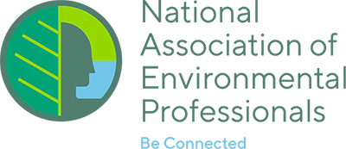
NAEP UPDATE

2019 NAEP Conference in Baltimore!
Excitement is brewing in Baltimore in anticipation of the next NAEP Conference, to be held there on May 19–23, 2019. Information on Sponsor and Exhibitor opportunities is available at https://naep.memberclicks.net/2019-conference-sponsorship.

Call for Papers for the NAEP Environmental Practice Journal
Environmental Practice, the peer-reviewed journal of the National Association of Environmental Professionals (NAEP) and published by Taylor & Francis, is soliciting original manuscripts from the professional and academic communities on a continuous basis. Publishing in Environmental Practice is also a great venue to showcase your expertise and continue your professional development. More information can be found at: https://www.naep.org/environmental-practice-journal.

Call for Articles for the News for the Environmental Professional: The Official Newsletter of the NAEP
The NAEP newsletter is published four times a year and emailed to all NAEP members. The newsletter is published in mid-February, May, August and November. Articles are accepted continuously, but the deadline for submissions for a particular newsletter is the end of the month prior to publication—for example, the deadline for the February issue deadline is January 31st. If you are interested in submitting an article, email newsletter@naep.org. More information on the newsletter is available at https://naep.memberclicks.net/naep-e-newsletter.

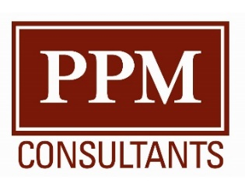

Thank you to our sponsor!

